External Api Improvements

1

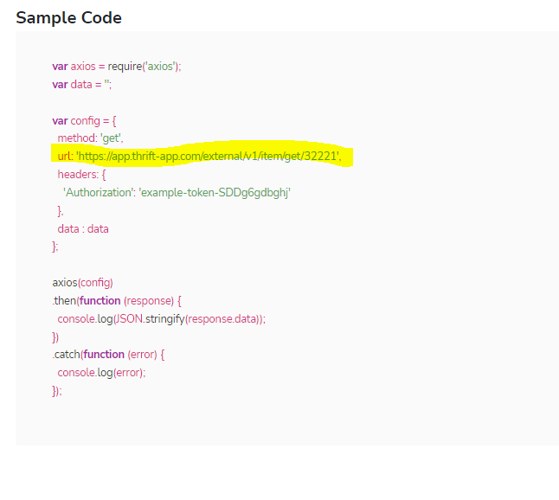

Highlight URL has no ? sign therefore, must be replace by <https://q.thrift-app.com/external/v1/item/get?itemId=1332>

2

Sample code of “create a new price request” contain this

"marketplaces": [ "ebay", "facebook" ].

We must replace this by "marketPlaces": [ "ebay", "facebook" ]

3

Providing itemDescription but even then get this message

data:

{

message: 'please enter barcode or descripition, please try again ',

success: false

}

4

'https://app.thrift-app.com/external/v1/item/get-list/1/10' this url must be replace by https://thrift-app.com/external/v1/item/get-list?page=1&pageSize=10